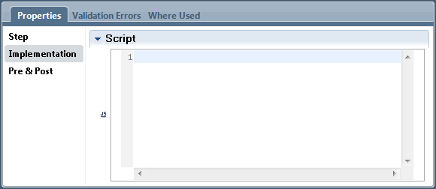
Full entry assist is available to help in building the script.
完整的输入帮助可以帮助构建脚本。

服务器的脚本 - Server Scriptlet
The purpose of this element is to assign text to a variable but provides an easy entry text input area into which the text can be entered.
这个元素的目的是将文本分配给一个变量，但提供了一个简单的条目文本输入区中可以输入的文本。
When added to the canvas, the Server Scriptlet step looks as follows:
当添加到画布上,服务器的脚本步骤看起来如下:
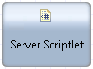
From the palette of steps, it looks like:
面板的步骤,它看起来像:
The implementation tab of this Step looks as follows:
这一步骤的实现选项卡看起来如下:
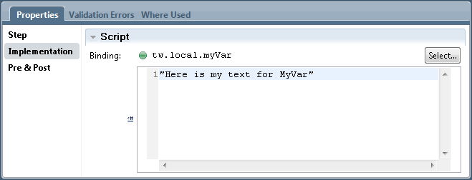
Be VERY careful here … adding quotes in the text adds quotes to the content. I have been bitten by this a number of times.
这里需要特别注意…在文本中添加引号来引用内容。我曾在这里吃过很多次亏。

修改任务 - Modify Task
The Modify Task component allows us to dynamically alter a number of the attributes of the current task within a Human Service. When added to the canvas, the Modify Task element looks as follows:
修改任务组件允许我们在一个人工服务中动态的修改当前任务的一系列属性。当添加到画布中时，膝盖任务的元素看起来如下：
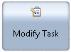
From the palette, it shows as:
在面板中，它显示为：
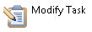
This element can change the characteristics of a Task under logic control.
这个元素可以改变任务逻辑控制的属性。
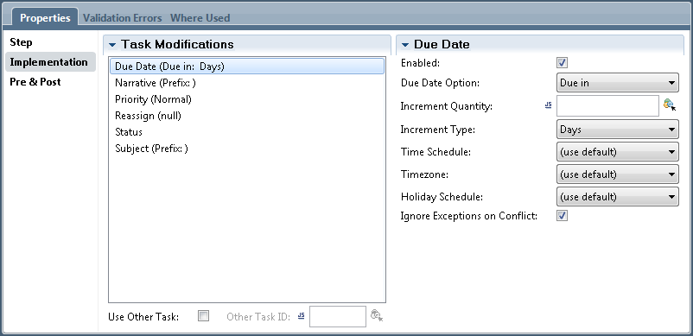

推迟任务 - Postpone Task
The postpone element allows a task to suspend itself for later processing. What is being postponed here is the completion of the task. The state of the service is saved for later retrieval. When inserted into a Service Editor diagram, the element looks as follows:
推迟元素允许暂停任务以便以后处理.在此,任务的完结是被推迟的一项。当前服务的状态会被保存，以便今后检索。在服务编辑器图中，它看起来如下：
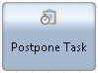
From the palette area, it looks like:
在面板中，它显示为：

When the Postpone is reached, the task is returned back to the in-box where it can be claimed again. If we want to hide the task for a period of time, we have to perform some additional work. One solution is to check at the conclusion of the Coach whether or not we suspended it and, if we did, pause the re-creation of the task for a period of time.
当一个推迟任务被调用时，当前任务被调回到收件箱中，以便再次调用。如果我们想讲任务隐藏一段时间，我们必须执行一些额外的工作。其中一个解决方案是，在Coach中检查是否应该要暂停它，如果暂停，则将重新创建任务的事件暂停一段时间。
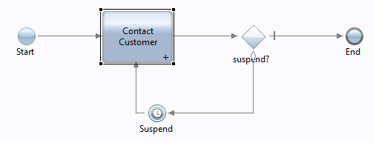
See also:
• Vimeo: Suspending a task for a period of time
另请参阅：
- Vimeo：将任务暂停一段时间

决策网关 - Decision Gateway
The decision gateway is used to route the execution path of the service based on the evaluation of an expression. The following shows a Decision Gateway in the diagram.
决策网关的作用是基于表达式的值来将服务分配到不同的执行路径中。下面的图显示了决策网关：
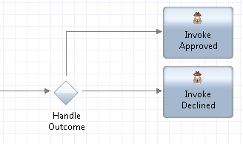
From the palette, this component looks like:
在面板中，它显示为：
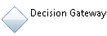
The implementation settings for the component has the following:
组件的实现设置有以下几点：
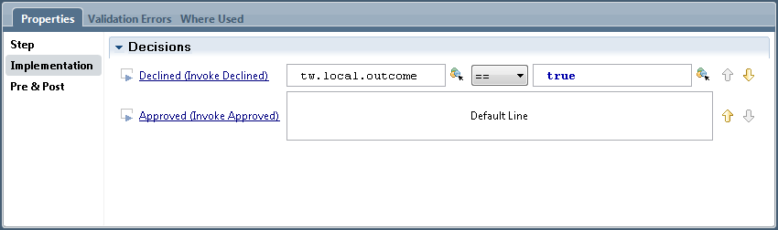
There will be a line for each possible path out from the component. One of the lines will be the default path that will be followed if none of the other expressions evaluate to true.
The labels for each line are of the form:
对于每一个可能的路径，在组件中都有对应一条连线。其中一条连线是默认的路径，在其他的表达式计算结果都不为真的时候使用。
link name (Step Name)
连接名称（步骤名称）
It is recommended to provide a label for each of the outgoing paths from the Decision Gateway otherwise they will show up as Untitled.
建议在决策网关的每条路径的连线都加一个标签，否则它将会显示成无标题。

结束事件 - End Event
The end event is used to mark the end of the service. On the diagram it looks as follows:
结束事件是用来标识服务结束的。在图中显示如下：
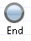
It has the same icon in the palette.
在面板中它的图标也是一样的。

注释 - Note
A note can be added into the diagram that provides an aid to a subsequent reader when trying to understand the solution. Text is added in a yellow box that can be positioned in the diagram. An example of how this looks is shown following:
注释是可以添加到流程图中，用来帮助其他用户理解当前流程的逻辑。文本是天骄在一个黄色的盒子里，这个盒子可以放在图中的任何位置。以下是一个显示的例子：
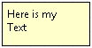
From the palette, the note has the following icon:
在面板中，它显示为：
The properties of the note contains a text input area into which the text for the note can be entered:
注释的属性中包含一个可输入的文本框，用来输入注释的。
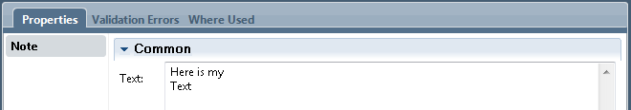
Having a note in the diagram does not effect the operation of the solution its purpose is solely for readability.
在图中添加注释并不会影响它的业务逻辑，只会增加可读性。

错误结束事件 - Error End Event
When added to the canvas, the Error End Event looks as follows:
当添加到图布中，错误结束时间看起来如下：
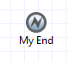
The purpose of this activity is to explicitly throw an error. This would be used when, during the processing of a service, it was detected that something problematic has occurred. For example, a request to purchase a product and the expiration of a credit card has passed or the product is not in stock.
这个活动的目的是为了显示地抛出一个错误。它的作用是，在服务处理中时候，用来发现一个问题。例如，当请求购买产品时候，使用了已过期的信用卡或者缺货。
Included in the Properties of this type of element is an Implementation section:
包含在此类型的元素的属性是一个可实现部分：
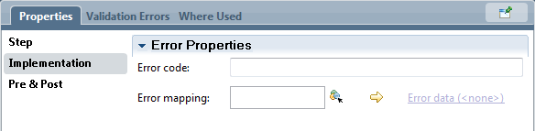

错误的中间事件 - Error Intermediate Event
When added to the canvas, the Error Intermediate Event looks as follows:
当添加到画布时，错误的中间事件看起来如下：
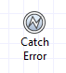
Included in the Properties of this type of element is an Implementation section:
包含在此类型的元素属性的实现部分如下：
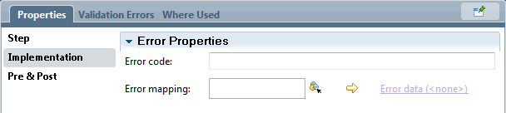

调用UCA - Invoke UCA
Within a Service, we may wish to invoke a UCA. Invoking a UCA can cause the creation of a new instance of a process. Remember that UCAs are usually associated with an external service or timer causing them to be invoked. Giving us the ability to initiate a UCA explicitly adds a lot more flexibility to solutions we may build. A primitive is supplied that allows us to explicitly invoke a named UCA.
在一个服务中，我们可能需要调用一个UCA。调用UCA会导致创建一个新的流程实例。需要注意的是，UCA通常是关联了一个外部服务或者是一个定时器，使它们可以被调用。UCA给我们提供了更多灵活的解决方案。比较显著是一个优点是，允许我们显示地调用一个UCA。
When added to the canvas, the UCA caller primitive looks as follows:
当被添加到画板时，UCA的调用者看起来如下：
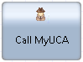
It is added by dragging a palette entry that looks like:
它可以通过面板中添加，图标如下：

Once added, its implementation properties look as follows:
添加后，它的实现属性如下：
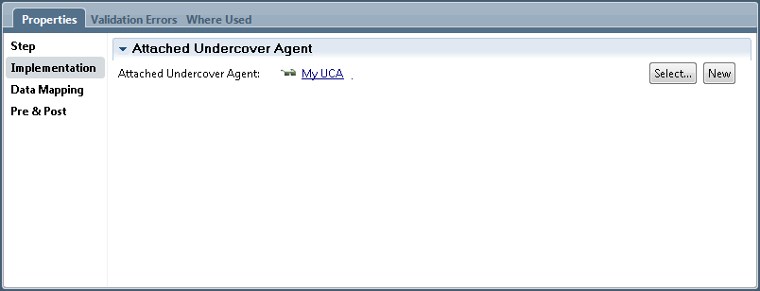
The UCA caller primitive's implementation names the UCA that is to be called. The Data Mapping section allows us to map the variables in scope in the process to the parameters expected by the UCA.
UCA调用者的原始实现标志着该UCA可以被调用。数据映射部分允许我们把流程中的变量范围映射到UCA所需要的参数中。
See also:
另请参阅：
• Undercover Agents (UCAs)

捕获异常 - Catch Exception
If an activity in a service can fail then it is wise to try and handle that failure by taking some remedial action even if it is only alerting an administrator. A Catch Exception handler can be added to activities that can generate failures. To add the handler, drag it from the palette and drop it onto the activity.
当服务中的一个活动失败时，它可以尝试去采取一些修补措施来处理这个错误，即使只是简单地给管理员发送一个警告信息。捕获异常处理程序可以被添加到活动中，来生成失败信息。通过在面板中添加程勋，拖放到活动中即可。
Here is an example with a Catch Exception added:
以下是一个添加捕获异常的例子：

